SUMMARY
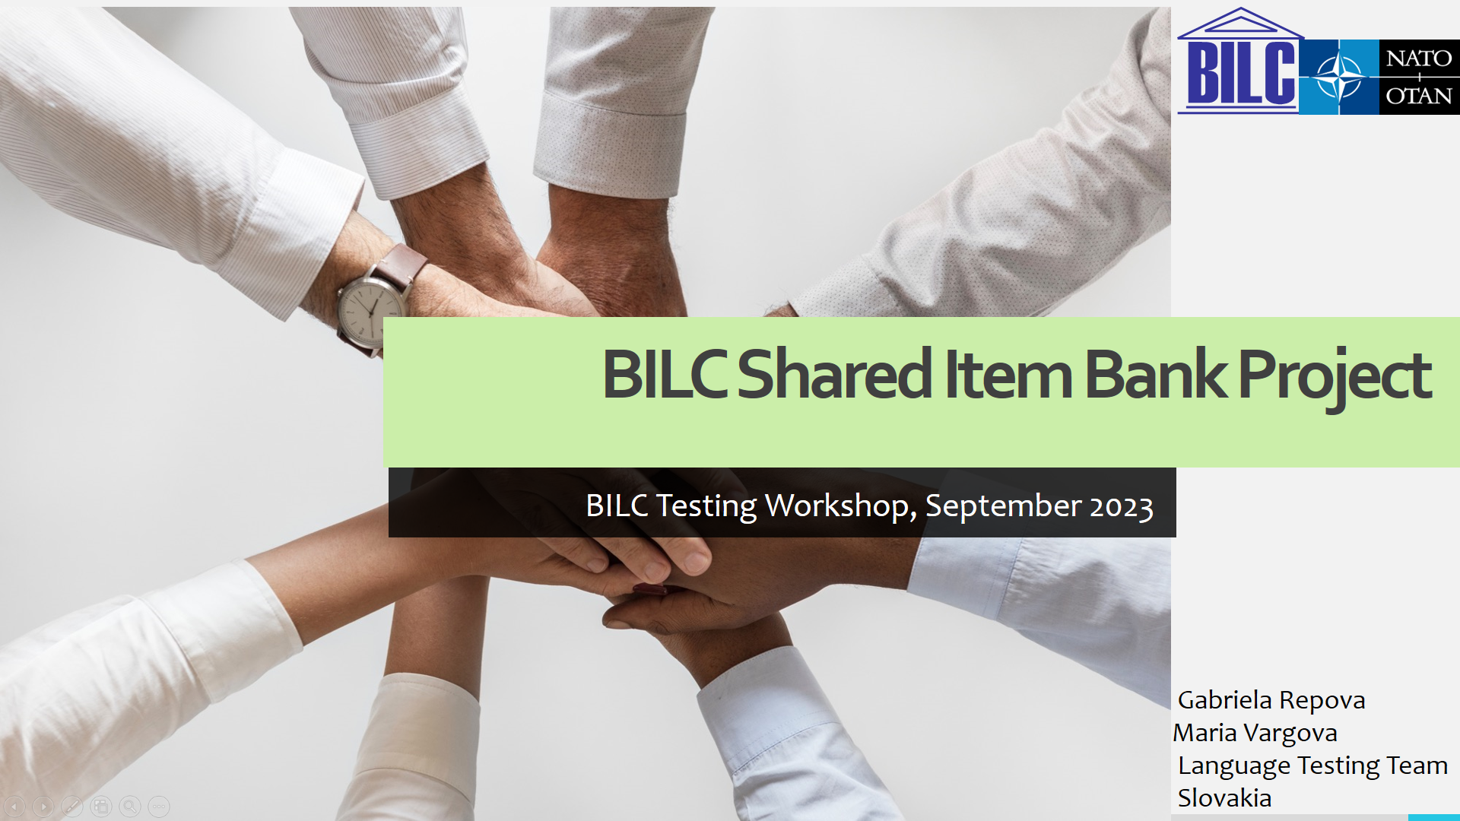
The presentation provides an update on the progress of the BILC Shared Item Bank project.
The presentation is in four parts.
Part 1 (Slides 2 – 3) describes the goals of the initiative and lists the WB members.
Part 2 (Slides 4 - 8) informs about the progress being done in case of the reading items
Part 3 (Slides 9) explains what has been done in the area of the listening items design
Part 4 (Slide 10) explains what the next phases of the project are

